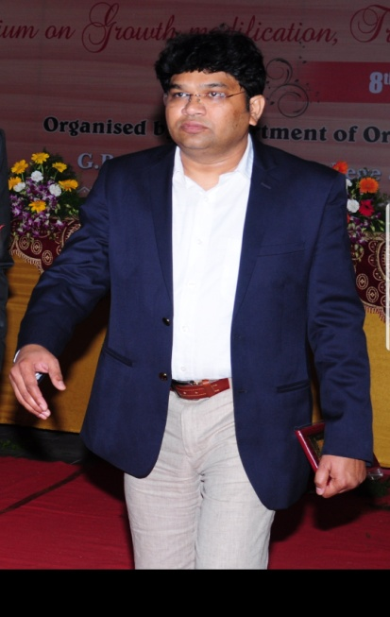Dr Sreekanth Cherukuri graduated from VS dental college Bangalore in 1998 and MDS in orthodontics and dentofacial orthopaedics from Rajiv Gandhi university of health sciences in 2002 Although his first choice was to be a full time clinician, his professional brilliance opened the doors to an academic career, started working as post graduate teacher in prestigious GPR Dental College & hospital ,AP and presently holds the position of professor and in charge head of the department of orthodontics. He is a passionate teacher and an avid learner and student of Orthodontics keeping in tune with the latest in Orthodontics and related sciences. During his 18 years of teaching, he has been a pg guide for around 25 MDS students and has to his credit more than 30 international and national publications.

Dr Cherukuri has special interest in Adult orthodontics and has been trained intensively in the technique of invisible orthodontics across the globe with leading lingual practioners. He was one of the pioneers to have started practicing lingual orthodontics way back in 2005 after getting trained under world renowned lingual orthodontist Dr Didier Fillion, France. He has to his credit more than 500 successfully completed lingual cases. He has been practicing other latest invisible orthodontics procedures like aligners, lingual matrix, incognito systems.

He is a firm believer in interdisciplinary dentistry and dental aesthetics and emphasizes on comprehensive treatment planning keeping ideal Orthodontic treatment goals in mind. To further illustrate his commitment to the profession, Dr. Cherukuri also maintains memberships with numerous prestigious organizations, some of which include; the American Association of Orthodontists (AAO), World federation of orthodontics(WFO), Indian orthodontic society(IOS),

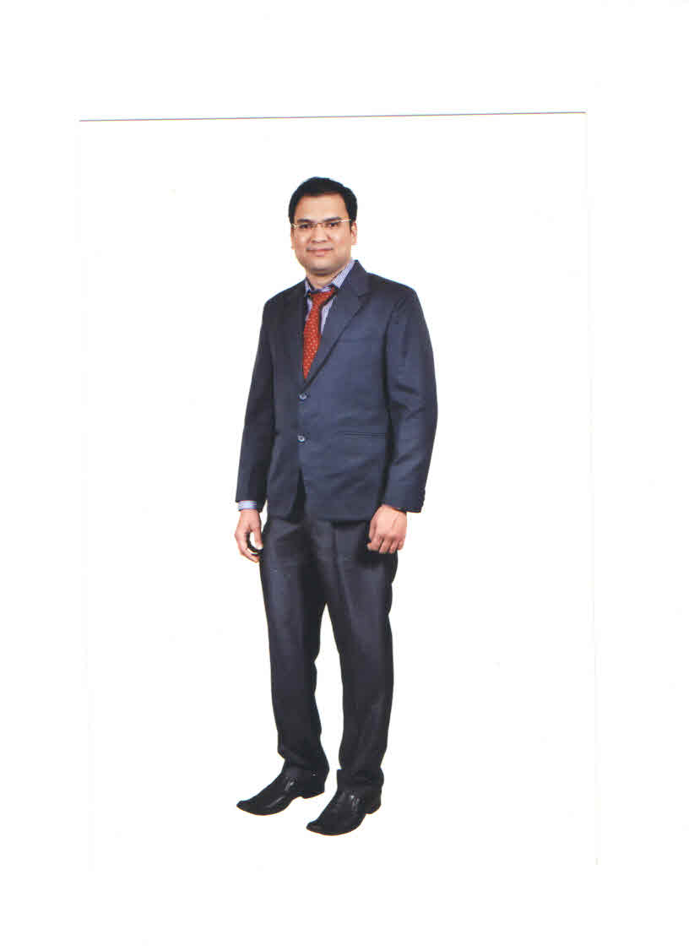Dr. Suhas Tarlapally, graduated with honors from M.S. Ramaiah Dental College And hospital, Bangalore and continued his education at Mamata Dental College  Department of Orthodontics. He received his gold medal in Orthodontics from NTR University of Health Sciences and became a specialist in the field of Orthodontics. Dr. Suhas Tarlapally has worked as faculty at mamata dental college, khammam, in department of Orthodontics for many years as well as being a consultant orthodontists at many private clinics in India.

His knowledge and experience makes him exceptionally well trained with the old and new technology, assuring you that you are in the best hands. He has taught many continuing educational courses to his colleagues and as well attended many continuing educational courses thus keeping him up to date in the field of Orthodontics.

He started using Invisible aligners and takes continuing educational courses to keep current with the most modern orthodontic treatments, Lingual Orthodontics, Jaw growth modulations and  TMJ treatment methods. He regularly sees many referrals (including family members) from various general dentists and dental specialist.

Dr.suhas tarlapally specialized in Orthodontics because he loves the challenge of improving somebody’s smile and self-confidence. Every patient that he treated always thanked him for the joy and happiness that brought to their lives because of their better and brighter smiles. In addition to his private practice, he is an active member of the Hyderabad Orthodontic society group(HOSG),  Indian orthodontic society(IOS), Fellow at World Federation of Othodontics(WFO), member of American Association of Orthodontics (AAO) and Telangana State Dental Association.

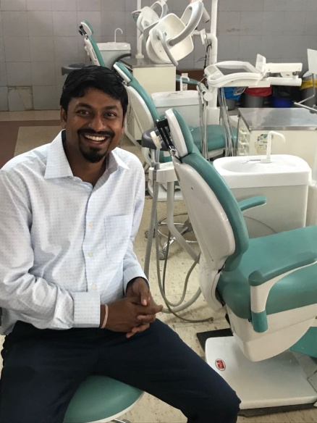 Dr Raghavendra Sunku  completed his  bachelors degree in dentistry from cods Davanagere In the year 2002 & Later got  in to M.D.S. through the COMEDK All-India level entrance test held in Feb 2004. Under able guidance of   Brigadier-General {Dr} Anmol Singh Kalha worked as resident in Orthodontics for 3 years at College of Dental Sciences and Hospital, Davangere, Karnataka, India. Completed Mastersin 2007  Both the under graduation & masters he has pursued from the Davnagere  Which is considered as Mecca of Dentistry

His keen interest was in Lingual Orthodontics and various Esthetic Orthodontics, Orthodontic Mini Implants, Self liagating systems like Damon systems, Smart clip

Various Non surgical options in orthodontic treatment, Surgical Orthodontics. And Invasline

His vast experience as a free lancer to various super speciality clinics & successful completed more than 10,000 happy patients. Presented research papers in various conferences at state & national level . Chaired the scentific session in various conferences

 After successfully clearing the aboard of  Orthodontics exam at sultanate of Oman in 2014 .  He  worked as senior consult for Amana modern medical  care.  Later was heading the department of Orthodontics at AMMC Muscat  He still keep am active visiting practice at AMMC sultanate of Oman till date .

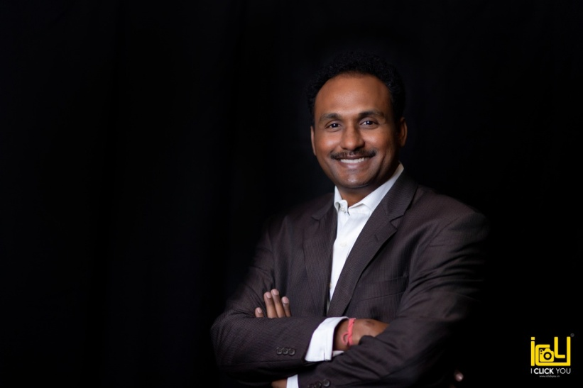 Dr.Sujan Kumar Kotta Venkata, graduated from SRM Dental College and Hospital, under the prestigious The TamilnaduDr.MGR Medical University and continued to pursue his postgraduation in the subject of Orthodontics and Dentofacial Orthopedics from Saveetha Dental College, one of the Premier Institute in the country in 2008. After education, with a passion to learn and teach, Dr.Sujan Kumar continued working in MNR Dental College and Hospital and currently holds the position of Professor and Post Graduate Guide in the Department of Orthodontics.

With ever developing technology in the field of Dentistry and Orthodontics, Dr Sujan Kumar keeps himself updated by attending courses, CDE’s, and workshops in India and abroad and thus transferring the knowledge gained in to his clinical practice.

He is trained in six different systems of Aligners, including INVISALIGN. He is one among the four Silver certified providers of Invisalign in Hyderabad. He is the official speaker of V Clear aligners and conducts guest lectures and workshops for the same.

With a view to create smiles invisibly, he is trained in Lingual Orthodontics from none other than Dr Rafi Romano of Israel and Dr Hee Moon Kyung of Korea and holds a certificate from Kyungpook National University, South Korea. He is also trained in the use of Mini Implants in Orthodontics by Dr.HyoSang Park and uses mini implants extensively in his practice.

With introduction of Customisation and Artificial Intelligence in to Orthodontics Dr.Sujan Kumar uses customized braces from Insignia and Incognito, Lingual Matrix and other systems to create perfect smiles and occlusion. Combination of art and science gives the best possible smiles to the patient.

With an interest and passion to create beautiful smiles, he pursued advanced studies in cosmetic dentistry and oral rehabilitation from New York University College of Dentistry.

He holds the position of Treasurer of Indian dental Association, Cyberabad Branch. An active member of Indian Orthodontic Society, Hyderabad Orthodontic Study Group and Telangana State Dental Association. As part of academics, he is associated with various research projects in the field of Orthodontics and published more than 20 scientific papers in national and international journals.